HYDRAPOWER DH 25022 AT TRACKER MARINE

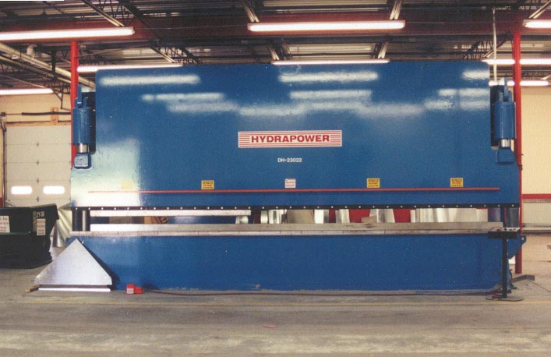

This HYDRAPOWER Press Brake is used to form the aluminum hulls for the TRACKER bass boats.

